**Assignment – 2. Central Tendency**

**The below shows the MEAN, MEDIUM and MODE of the Placement dataset.**

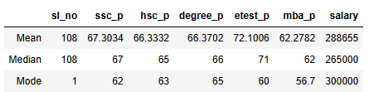

**Result/ Observation:**

**In ssc_p, hsc_p, dgree_p and mba_p the student scored the average mark 66% but in etest_p alone they students scored 72 % which is in the Good Category. This class studies are average performer.**

**The mean for the salary is 2,88,655 and the Median for the salary is2,65,000 which is less than the mean. So, I found the outlier in the medium of Salary part.**

**The repeated mark score by the students (Mode):**

**ssc_p = 62%**

**hsc_p = 63%**

**degree_p = 65%**

**mba_p = 56.7%**

**Their repeated earned salary is 300000.**